**Assignment No. 15**

*Title:*

To study the SSL protocol by capturing the packets using Wireshark tool

while visiting any SSL secured website (banking, e-commerce etc.)

*Outcomes:*

Retrieve SSL protocol by capturing the packets using Wireshark.

*Theory:*

**SSL, or Secure Sockets Layer,** is an encryption-based Internet security protocol. It

wasfirst developed by Netscape in 1995 for the purpose of ensuring privacy,

authentication, and data integrity in Internet communications. SSL is the predecessor

to the modern TLS encryption used today.

*How does SSL/TLS work?*

In order to provide a high degree of privacy, SSL encrypts data that is transmitted

acrossthe web. This means that anyone who tries to intercept this data will only see a

garbled mix of characters that is nearly impossible to decrypt.

SSL initiates an authentication process called a handshake between two

communicatingdevices to ensure that both devices are really who they claim to be.

SSL also digitally signs data in order to provide data integrity, verifying that the data

isnot tampered with before reaching its intended recipient. There have been several

iterations of SSL, each more secure than the last. In 1999 SSLwas updated to become

TLS.

*Why is SSL/TLS important?*

Originally, data on the Web was transmitted in plaintext that anyone could read if

they intercepted the message. For example, if a consumer visited a shopping website,

placed an order, and entered their credit card number on the website, that credit card

number would travel across the Internet unconcealed.

SSL was created to correct this problem and protect user privacy. By

encrypting any data that goes between a user and a web server, SSL ensures that anyone who

intercepts the data can only see a scrambled mess of characters. The consumer's credit card number is

now safe, only visible to the shopping website where they entered it.

SSL also stops certain kinds of cyber attacks: It authenticates web servers, which is

important because attackers will often try to set up fake websites to trick users and

steal data. It also prevents attackers from tampering with data in transit, like a

tamper-proof seal on a medicine container.

*Are SSL and TLS the same thing?*

SSL is the direct predecessor of another protocol called TLS (Transport Layer

Security).In 1999 the Internet Engineering Task Force (IETF) proposed an update

to SSL. Since this update was being developed by the IETF and Netscape was no

longer involved, the name was changed to TLS. The differences between the final

version of SSL (3.0) and the first version of TLS are not drastic; the name change

was applied to signify the change in ownership.

Since they are so closely related, the two terms are often used interchangeably and

confused. Some people still use SSL to refer to TLS, others use the term "SSL/TLS

encryption" because SSL still has so much name recognition.

***SSL PROTOCOL Wireshark :***

**Step 1: Open a Trace**

*1*

*. Open the Wireshark trace*

You should see the following trace.

Figure 1: Trace of “HTTPS”

traffic

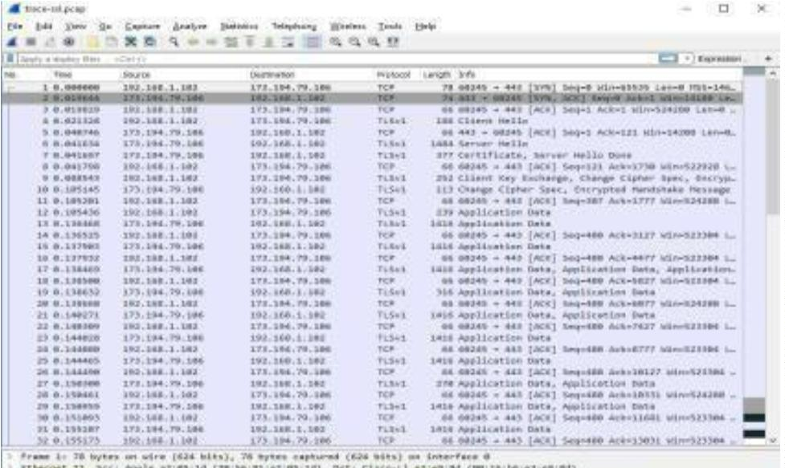

**Step 2: Inspect the Trac**

Now we are ready to look at the details of some “SSL” messages.

To begin, enter and apply a display filter of “ssl”. (seebelow)

This filter will help to simplify the display by showing only SSL and TLS

messages.It will exclude other TCP segments that are part of the trace, such as

Acks and connection open/close.

Figure 2: Trace of “SSL” traffic showing the details of the SSL header

Select a TLS message somewhere in the middle of your trace for which the

Info reads “Applica tion Data” & expand its Secure Sockets Layer block

(by using the “+” expander or icon). For in stance, packet #12 (see

below).

Application Data is a generic TLS message carrying contents for the

application, suchas the web page. It is a good place for us to start looking at

TLS messages.

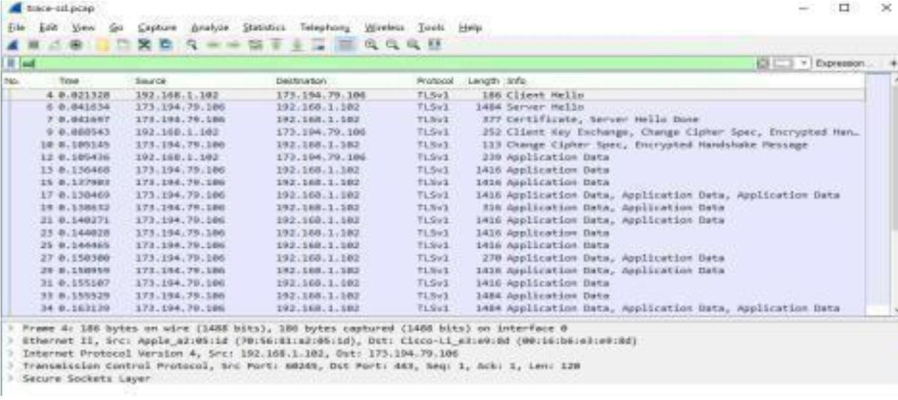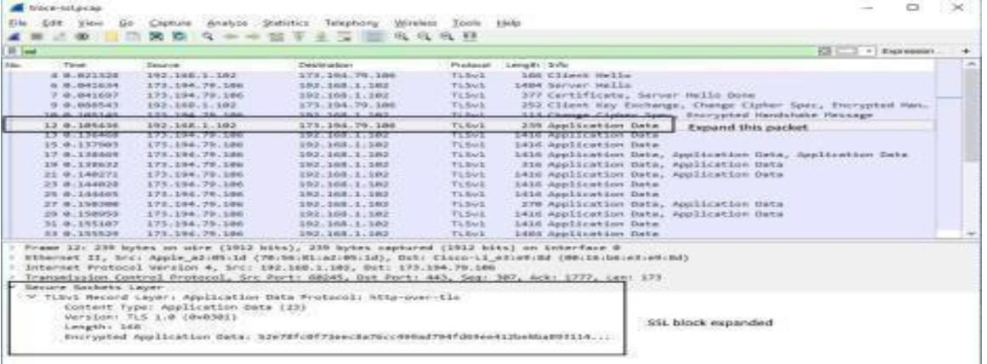

The lower layer protocol blocks are TCP and IP because SSL runs on top of

TCP/IP.The SSL layer contains a “TLS Record Layer”. This is the

foundational sublayer for

within the TLS Record.For these initial messages, an encryption scheme is

not yet established so the contentsof the record are visible to us. They contain

details of the secure connection setup in a Handshake protocol format.

Select packet #4, which is a TLS Client Hello message.

We can see several important fields here worth mentioning. First, the

time (GMT seconds since midnight Jan 1, 1970) and random bytes (size

2

8) are included. This willbe used later in the protocol to generate our

symmetric encryption key. The client can send an optional session ID to

quickly resume a previous TLS connection and skip portions of the TLS

handshake. Arguably the most important part of the Client Hello

message is the list of cipher suites, which dictate the key exchange

algorithm, bulk encryption algorithm (with key length), MAC, and a

pseudo -random function. The listshould be ordered by client

preference. The collection of these choices is a “cipher suite”, and the

server is responsible for choosing a secure one it supports or return an

error if it doesn’t support any. The final field specified in the

specification is for compression methods. However, secure clients will

advertise that they do not support compression (by passing “null” as the

only algorithm) to avoid the CRIME attack.

Finally, the Client Hello can have a number of different extensions. A

common one is server_name, which specifies the host name the

connection is meant for, so webservershosting multiple sites canpresent

the correct certificate.

In our case, the client likely sent no session ID as there was nothing

to resume (see below).

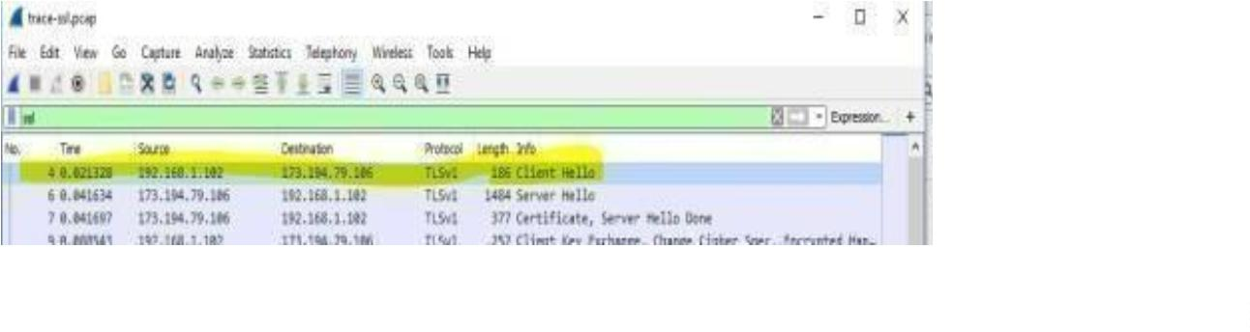

1

. Select packet #6, which is a TLS Server Hello message

The session ID sent by the server is 32 bytes long. This identifier

allows later resumption of the session with an abbreviated

handshake when both the client andserver indicate the same value.

The Cipher method chosen by the Server is TLS_RSA_WITH_RC4_128_SHA

(0x0005). The Client will list the different cipher methods it supports, and the

Serverwill pick one of these methods to use.

*Certificate Messages*

2

. Next, find and inspect the details of the Certificate message including

expandingthe Handshake protocol block within the TLS Record (see below

for expansion of packet #7).

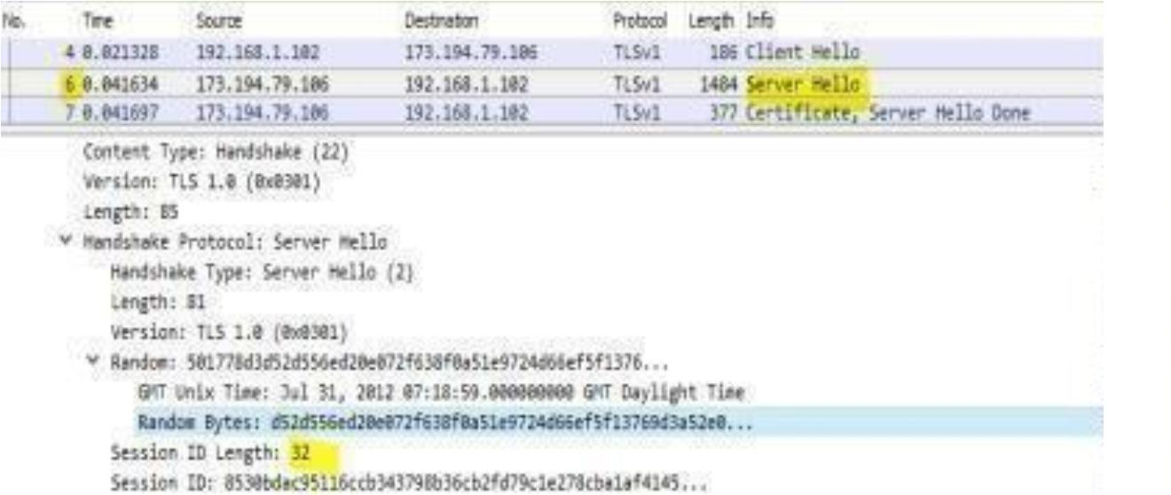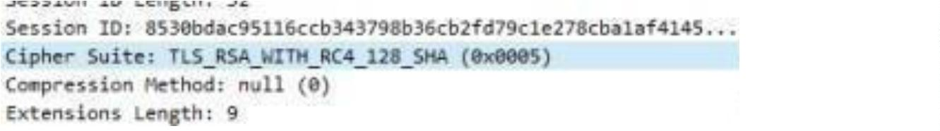

As with the Hellos, the contents of the Certificate message are visible

because an encryption scheme is not yet established. It should come

after the Hello messages.

Note it is the server that sends a certificate to the client, since it is the browser

that wants to verify the identity of the server. It is also possible for the server to

request certificates from the client, but this be behavior is not normally used by

web applications.

A Certificate message will contain one or more certificates, as needed for one

party to verify the identity of the other party from its roots of trust certificates.

You can inspectthose certificates in your browser.

*Client Key Exchange and Change Cipher Messages*

3

. Find and inspect the details of the Client Key Exchange andChange

Ciphermessages i.e. packet #9 (see below)

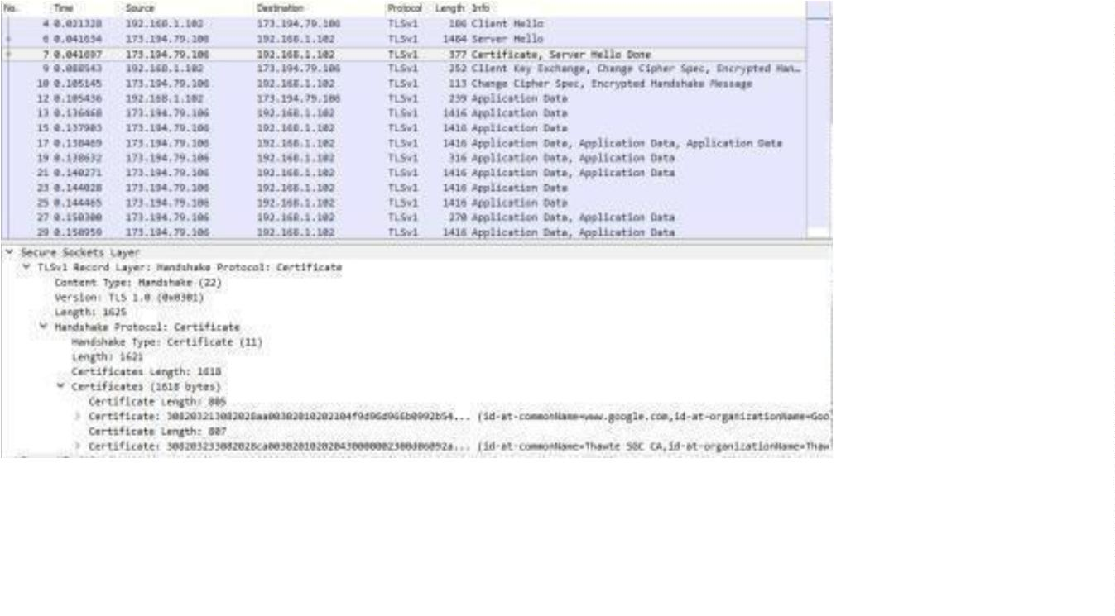

The key exchange message is sent to pass keying information so that both sides

will have the same se create session key. The change cipher message signal a

switch to a new encryption scheme to the other party.

This means that it is the last unencrypted message sent by the party.

Note how the Client Key Exchange has a Content-Type of 22, indicating the

Handshake protocol. This is the same as for the Hello and Certificate

messages, as they are part of the Handshake protocol.

The Change Cipher Spec message has a Content-Type of 20, indicating the

ChangeCipher Spec protocol (see packet #10 – see below).

That is, this message is part of its own protocol and not the Handshake

protocol. Both sides send the Change Cipher Spec message immediately

before they switch tosending encrypted contents. The message is an indication

to the other side. The contents of the Change Cipher Spec mes sage are

simplythe value 1 as a single byte.

Actually, it is the value “1” encrypted under the current scheme, which uses no

encryption for the handshake so that we can see it.

*Alert Message*

1

. Finally, find and inspect the details of an Alert message at the end ofthe

trace(packet #42).

The Alert message is sent to signal a condition, such as notification that one

party is closing the connection. You should find an Alert after the Application

Data messagesthat make up the secure web fetch.

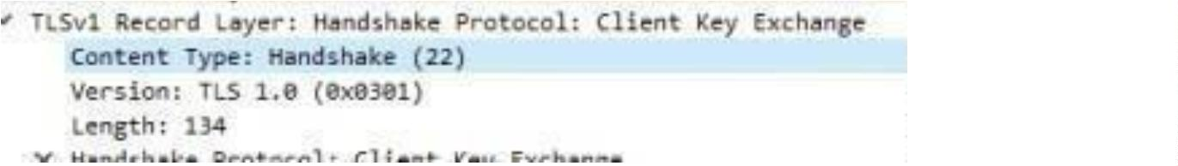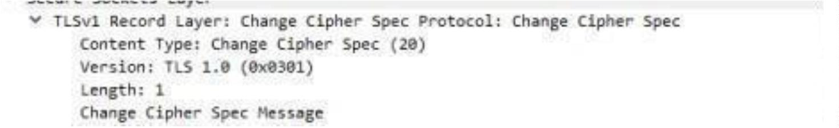

Note, the Content-Type value is 21 for Alert. This is a new protocol,

different from the Handshake, Change Cipher Spec and Application Data

values that wehave already seen.

The alert is encrypted; we cannot see its contents. Wireshark also describes the

message as an “Encrypted Alert”. Presumably is it a “close_notify” alert to

signal thatthe connection is ending, but we can not be certain.

*Conclusion:*

Hence we had studied the SSL protocol by capturing the packets

using Wireshark tool while visiting any SSL secured website

(banking, e-commerceetc.)

